25th March 2015

Name

Dear

Regatta for the Disabled Sponsored Accessible Boating Day at Bisham Abbey
On the 29th of May 2015 Regatta for the Disabled (R4D) are sponsoring a day of Bell Boating fun on the water at the National Sports Centre, Bisham, near Marlow and we are writing to invite those of your members who would like to attend.
Bell Boating is a safe and fun way for people with disabilities and their carers to have a close to water experience. R4D will be working with the Rivertime Boat Trust who took over 350 participants Bell Boating at the National Sports Centre in 2014 and will take more than 800 participants out in 2015.
On the 29th of May we have arranged a morning and afternoon session, which will run from 9:30am to 12noon and then 1:00pm till 3:30pm. We can accommodate up to 30 participants in each session. There is a picnic area and onsite restaurant available to for you to use before during and after the sessions if you wish.
The Rivertime Boat Trust will provide support staff and Bisham Abbey Sailing School will provide all the qualified staff for the event. All you do is bring the participants, the appropriate care provision, a change of clothes, hats, sunscreen, and a picnic.
Carers will be asked to go Bell Boating with their participants if necessary but if the person can be on their own you must stay on site and if you would like to bring other family members or members of your group to watch the fun you can but we would like them to sign in on the day. Taking part is free for everyone; however, as the places are limited to 60 seats for the total day please return your application promptly and by 15 May 2015. Places will be allocated on first received basis.
To take part please complete the attached form and return it to
Regatta for the Disabled
c/o Bisham Abbey Sailing and Navigation School, National Sports Centre,
Marlow Road, Bisham, Nr Marlow
Buckinghamshire SL7 1RR Tel: 01628 474960.

We will contact you by email week beginning 18 May 2015 to confirm your entry

Best wishes

Ian Tritton
Chairman
Regatta for the Disabled

Frequently Asked Questions.
Who are Regatta for the Disabled and what do they do?
Regatta for the Disabled is a registered charity organising an event at Phyllis Court in Henley on Thames on 5 September 2015. Our aim is to provide accessible river and riverside activities that people of mixed abilities can take part in together. Also we keep the entrance cost to a minimum and in fact do not charge carers.
2015 marks the sixth year of this exciting and unique day out for disabled children and their families, promising a huge variety of land based and river based events.
The river events in particular, provide access to boats not normally available to people with a disability.
With interesting and exciting trade stands, and activities such as Punch and Judy, a climbing wall that will take wheel chairs, a farm yard, catering and of course, trips on the river Thames on board a number of boats including ‘Rivertime’, which has been specially built to accommodate disabled passengers. R4D offers everything for a great day out.
Not only is this event open to disabled people; it is a great opportunity for family and friends to join in the fun too!
www.regattaforthedisabled.org
With thanks to our main supporter
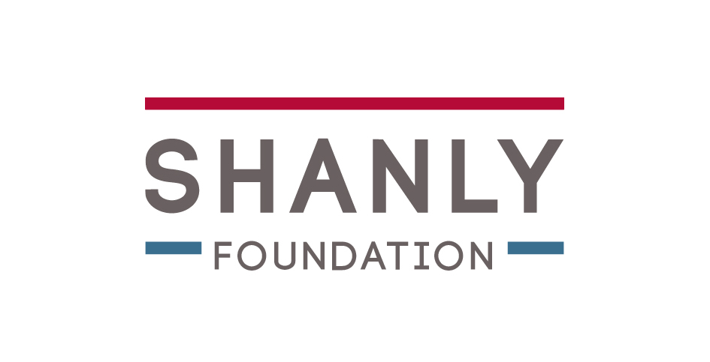
Who are the Rivertime Boat Trust (RBT) and what do they do?
RBT co-founders, Pat and Simon Davis have lived and worked on the River Thames for most of their lives. They created the charity 6 years ago and built a wheel chair accessible river cruiser called Rivertime. With the support of 50 volunteers Rivertime has taken out more than 12,500 people with a range of needs on the Thames for trips.
What is a bell boat?
Bell Boats are a like two giant Canadian canoes linked together with a platform to create catamaran. This creates a very stable craft that is 9.5m long and 1.5m wide. This size allows us to seat up to 10 participants in each bell boat plus a qualified helm.
What will we do in a bell boating session?
In each session the participants and carers will be fitted into a buoyancy aids, taught how to paddle on the land, moved onto a bell boat and taken for a short paddle loop, returning to the pontoons. Assuming all is well, we will then go for a longer paddle, maybe stopping for drink on the way. When we return from the paddle we will have a short break and then play some on the water games like tug of war or bell boat racing. This easily fills 2 hours and sometimes longer!

Who can take part?
Anyone older than 10 years with enough core strength to sit on a bench un-aided plus a carer can come paddling with us. The participants will be encouraged to paddle with everyone else. However the helm has all the ability to operate the boat alone if required.
What happens if it’s raining?
The event will carry on. We have tents outside to take shelter from the rain or sun and we have chair accessible changing rooms with toilets and showers if anyone needs to get changed after they have been bell boating.
How many people can I bring?
We are happy for you to come as groups to make your travel arrangements as simple or flexible as possible. We have allowed for 3 participants and carers to apply on one form. If you have a larger group then please to copy the form and send the details to us clipped together. If you also have a member of your group that is a chair user we can arrange for them to take a trip out in our Wheelyboat (wheelchair accessible powerboat) but please do remember to ensure you have enough care provision so that no one from your group is left alone at any time.
Why run the event with Bisham Abbey Sailing School at the National Sports Centre.
The Sailing School, founded in 1991 is an independent commercial business that operates within the grounds of The National Sports Centre. Their support enables us to offer sole usage of the river frontage that enables us to create the safe environment, specific to this event. The Sailing School have a lot of experience in working with people with special needs, they have been a RYA Sailability centre for 18 years.
Where can I find more information?
More information about the day can be found on our website, our twitter feed...@RFTDhenley or on RBTs Twitter feed @RBTBellboating or call 01628 474960

Application form.
Thank you for applying to take part in R4D’s Bell Boating day on the 29th May 2015.
Please fill in as much detail as possible on the form below and return it by post:
Your details
Participant Name (1) __________________________________________________________
Participant Name (2) __________________________________________________________
Participant Name (3) __________________________________________________________
Carer Name (1) __________________________________________________________
Carer Name (2) __________________________________________________________
Carer Name (3) __________________________________________________________
Would like to bring non-participating family in support (Y/N) _________
Would like to make use of the Costa facilities whilst on site (Y/N) ______
Would like to bring additional chair users to take a ride in the Wheelyboat. (Y/N) _______
Lead carer contact details.
Forename _________________________Surname ____________________________
Address line 1 __________________________________________________________
Address Line 2 __________________________________________________________
Address Line 3 __________________________________________________________
Postcode __________________________________________________________
Telephone number __________________________________________________________
Email Address __________________________________________________________

Please note any additional information

